Lab#12 Publish your college webpage (Lab 4 OR Lab 8) using GitHub Pages.
Final Outcome:

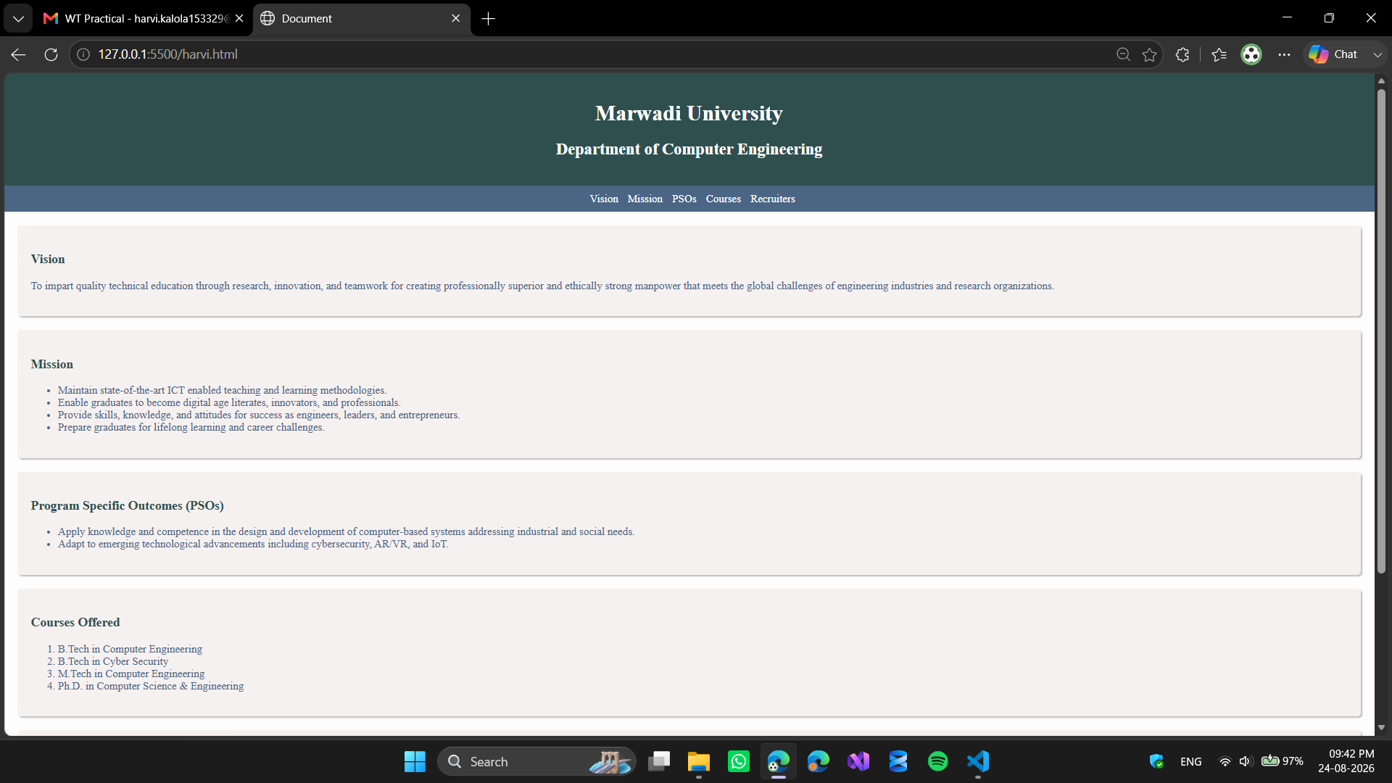
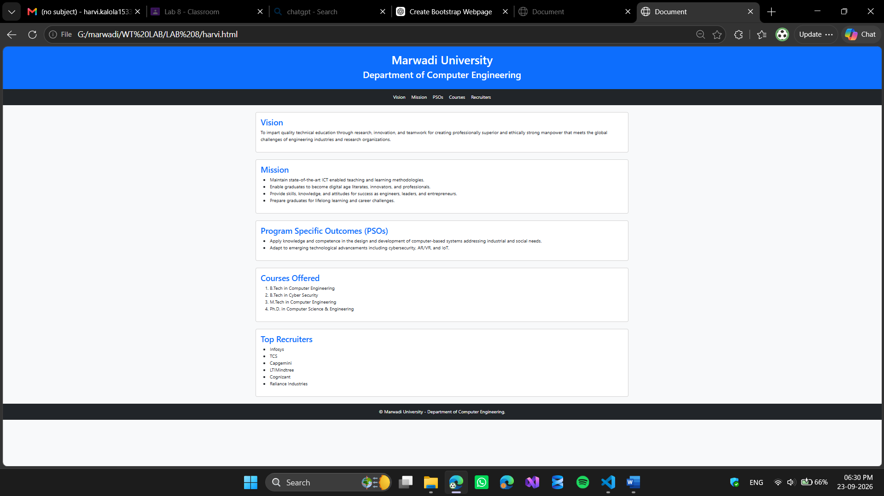

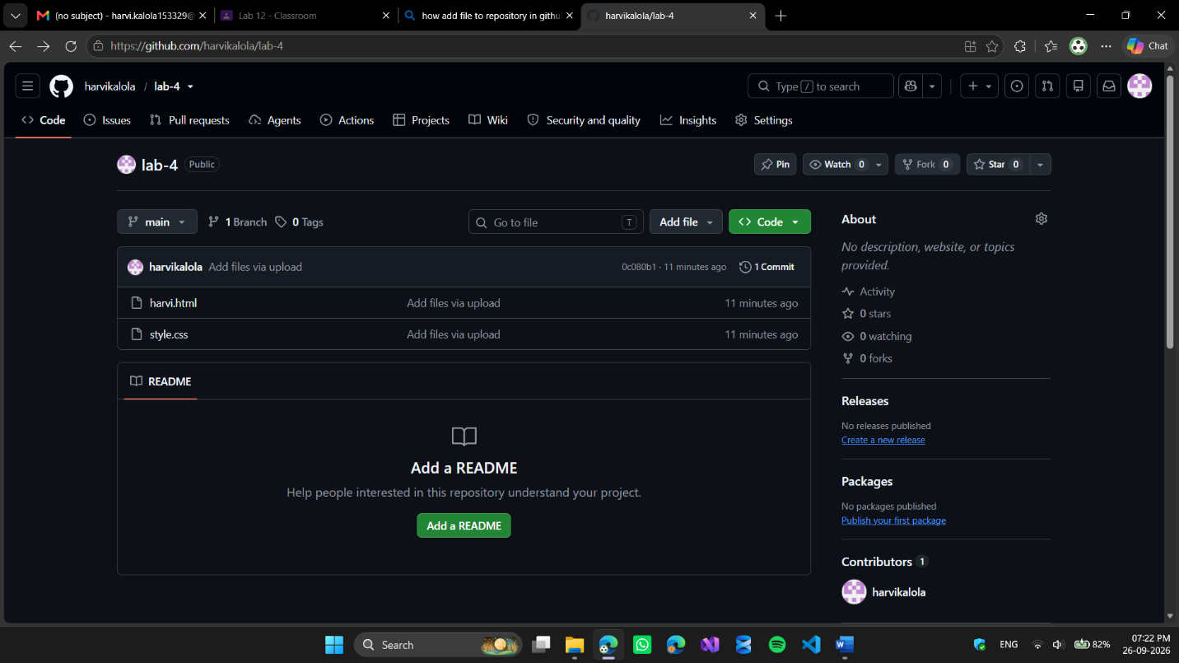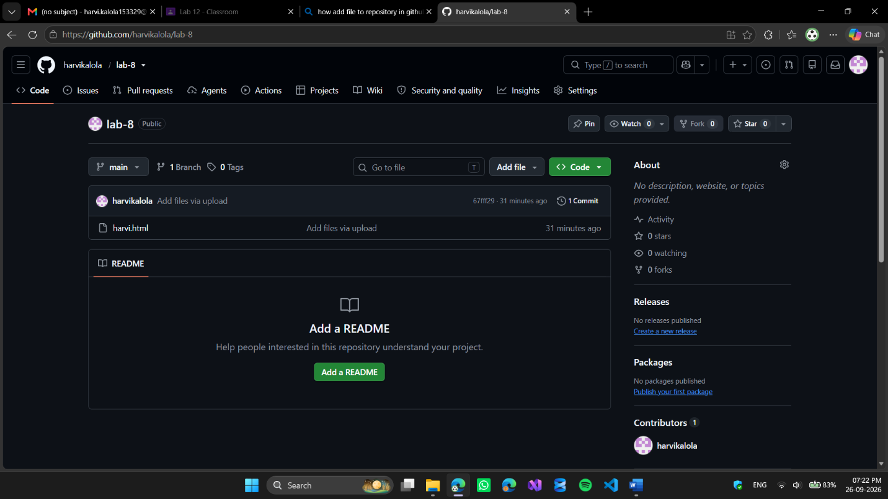

Code Snippet:

https://github.com/harvikalola/lab-8.git

https://github.com/harvikalola/lab-4.git

